Knowledge Organiser - History | Topic: Anglo-Saxons and Scots | Year: 4
Diagrams
Anglo-Saxon migration
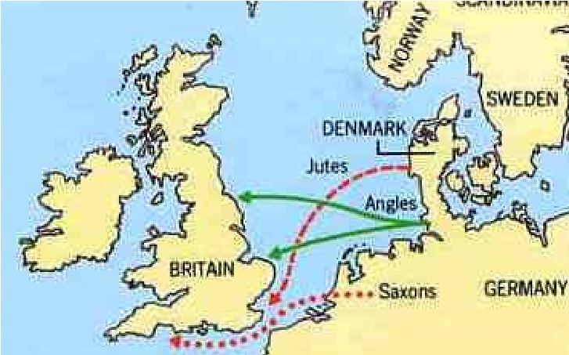

Seven kingdoms of Anglo Saxon Britain
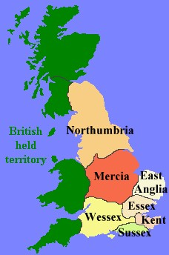

What should I already know?
- The Stone Age was when early humans used tools from stone. This lasted until the Bronze Age.
- The Bronze Age began when settlers arrived from Europe to Britain. These settlers brought with them ways of making tools from metal (bronze).
- The Iron Age lasted from 800 BC till the Roman invasion (AD 43) - this was when people used tools made from iron.
- In AD 43, the Romans under the order of Emperor Claudius, first invaded
Britain and Roman rule lasted until AD 410.
Stone Age
Palaeolithic Britain: early
humans first use tools
from stone

approx. 800,000BC
-

Mesolithic Britain: end
of Ice Age to start of
farming

approx. 10,5000 BC

Neolithic Britain:
start of farming

approx. 4,000 BC

Bronze Age: settlers arrived
from Europe and brought
ways to make tools with
metal approx. 2,000 BC

Iron Age: people made
tools from iron

Romans first
invade Britain

 | People
Bede | A monk who wrote about life in Anglo-Saxon Britain.
Gildas | A monk who wrote about the leaders of Britain offering land and food in exchange for protection against the Picts and Scots.
Hengist and Horsa | The Jute leaders who were invited to Britain by Vortigen to help defend them from the Picts and Scots in exchange for land.
King Alfred the Great | The King of Wessex who eventually became the first king of England.
King Ethelbert | The King of Kent who converted to Christianity.
St Augustine | A monk who helped spread the word about Christianity.
Vortigen | A king in Britain who offered Hengist and Horsa land and food in exchange for protection.

 | Vocabulary
AD/CE | Anno Domini –Used with a date to show how many years since the birth of Christ. Eg: it is now 2019 AD.  AD is sometimes replaced by CE which stands for Common Era.
Angles | people from Germany who invaded Britain around AD 410
Anglo-Saxon | the name given to the people who travelled from Germany and South Denmark and settled in Britain around AD 410
archaeologist | someone who studies the past by exploring old remains
artefact | an object from the past that shows evidence of what life was like
BC | Used with a date to show the number of years Before Christ
century | a period of 100 years
Christianity | the region based on the teachings of Jesus Christ
Danelaw | The name given to parts of the country ruled by the laws of Danes.
invasion | to try and take over a place by force
Jutes | people from the Jutland peninsula (Germany and Southern Denmark) who invaded Britain around AD 410
migration | movement from one place to another in order to settle there
monk | a member of a male religious community
pagan | a person who follows a religion that is not a major religion, including Christianity, Islam, Judaism, Buddhism, Hinduism, and Sikhism
Picts | ancient tribes who lived in northern Scotland
Saxons | people from northern and central Germany who invaded Britain around AD 410
Scots | people from Ireland who eventually settled in Scotland
settler/ settlement | people who migrate to a new place. When people start a community, this is a settlement
source | where something comes from
Key Knowledge
Sutton Hoo | In 1939, archaeologists discovered an Anglo-Saxon ship burial at Sutton Hoo in Suffolk.
Place names | Many of today’s place names come from Anglo-Saxon words Eg: Birmingham, Oxford, Butterwick
Language | Many of today’s English words are based on Saxon words Eg: days of the week, England
King Offa | King of Mercia. A powerful king, he built Offa’s dyke, to divide England & Wales.

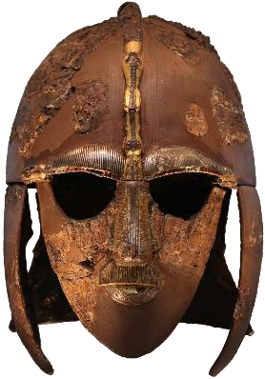
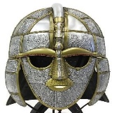

AD 396 - 398: Picts, Scots and Saxons constantly raid Roman Britain

AD 450: The Anglos-Saxons began to settle alongside the Britons.

AD 597: St Augustine helps missionaries spread the word about Christianity. King Ethelbert converts to Christianity. constantly raid Roman Britain

AD 789: The Vikings begin to raid Britain.

Timeline
AD 500: Britain is divided into 7 Anglo-Saxon kingdoms.

AD 731: Bede completes the Ecclesiastical History of the English Peoples.

AD 410: Romans leave Britain to defend Rome which was under attack. Angles, Saxons and Jutes make their way from Germany and South Denmark.

