Vocabulary
Egremont Castle, which stands above the River Ehen, was founded by William de Meschines in around 1130-1140.
The castle was granted its royal charter by Henry III in 1267.
Egremont Castle resisted repeated fierce attacks by Scottish raiders in 1138 and in 1315 and 1322.
When the Castle fabric began to decay, some of the stone was taken by local townspeople, and was used to replace the shop and house fronts on the Main Street and in the Market Square, some of which date back to the 15th century.

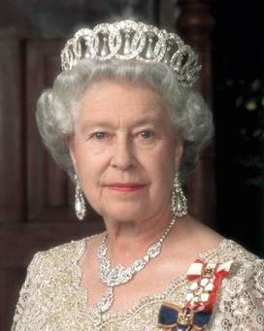Queen Elizabeth II lives in Windsor Castle and has done since 1953.

Key Knowledge
- Castles were built to defend and protect from raiders.
- Castles house royal families as well as others including Jesters and servants.
- The Queen’s Castle is called Windsor Castle. Her other homes include Buckingham Palace and Balmoral.
- Castles were built on high ground often surrounded by or near water. Castles would be built within a settlement.
Castle-A secure building made of stone, built to protect people in the castle from enemies.  Moat-A deep wide trench surrounding a castle, usually filled with water.  Portcullis – A protective door to the castle.  Gate-A barrier used to close an opening of a wall.  Drawbridge-A platform that can be raised or lowered over a moat to allow entry to the castle.  Sword-A weapon with a long metal blade.  Shield-A broad piece of metal used as protection against others or weapons.  Keep-The strongest and most secure part of the castle.  Battlement: The open space in a castle wall from which to launch weapons at the enemy.  Armour: Metal covering worn to protect the body in battle.  Dungeon: A dark, underground prison.  Turret: A small tower on top of a larger tower.  Flag: A piece of material used as a symbol.  Arrow slit: A narrow opening in a wall to shoot or look through.  Motte: A mound forming at the site of a castle.  Bailey: The outer wall of a castle.  Jesters: a professional joker.  King: A male ruler.  Queen: A female ruler.  Have you been to a Castle?  What was it called? | 1066 The first castle was built. 1070 William the Conqueror started building Windsor Castle. 1092 Carlisle Castle is built to act as a barrier against the Scots. Timeline 1130 Egremont Castle is built  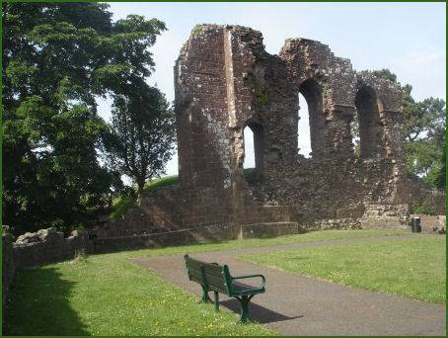  Egremont Castle

